Irish Rowing Adventures
2027 Sample Tour -- Date to be confirmed
The perfect holiday for paddlers exploring the real Ireland

Based in the heart of Ireland’s Ancient East we can offer rowing club groups of 10, 15 or 20 people the chance to negotiate ancient navigations and scenic gems. At night stay in cosy rooms at our base right on the river bank in the medieval village of Graiguenamanagh, Co. Kilkenny. Relax and just arrive as all logistics will be sorted for you, all boats and top class equipment waiting for you, and a super warm Irish welcome from your hosts.

The Irish Rowing Adventure is an exciting rowing tour organised by Brian & Brigid Roberts at their historic and beautiful guesthouse in Graiguenamanagh. All river based activities are coordinated by Brian & Brigid and the team at Irish Rowing Adventures. Accommodation and meals, as well as onshore entertainment, are perfectly managed on your behalf by our team at iconic Waterside Guesthouse in Graiguenamanagh. Brian Roberts is proprietor of Waterside Guesthouse, has been involved in rowing for 45 years, and is also founder of Graiguenamanagh Rowing Club, a vibrant and growing club established in 2001.

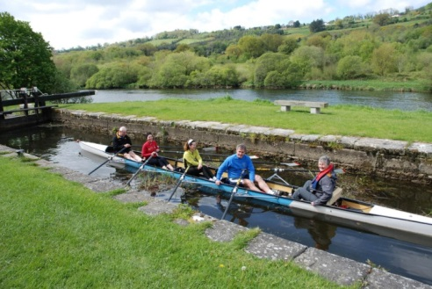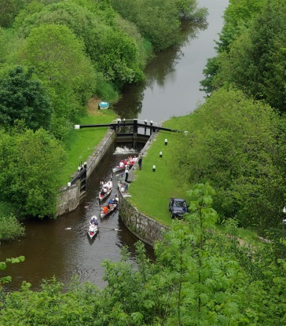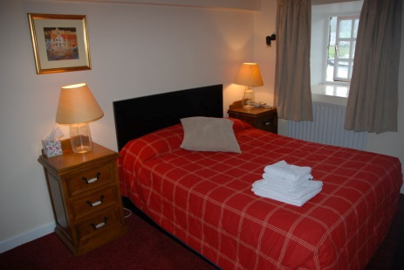
Negotiating a Barrow lock Clashganny Lock Cosy room at Waterside

Graiguenamanagh and this corner of Ireland has a wealth of good rowing, but is also steeped in ancient and modern Irish heritage. It would be a shame to miss out on this while you are here, and so we also include traditional Irish pub music nights and visits to the medieval city of Kilkenny. In Graiguenamanagh itself you will feel the heritage in every stone in every building from 800 year old Duiske Abbey to the still thriving ancient woollen Mills at Cushendale.

Further information available from
Brian Roberts, Irish Rowing Adventures, Waterside ,Graiguenamanagh
Tel 00353-59-9724246 mobile;0035386 8234813
Facebook and Instagram; Irish Rowing adventures
brian@watersideguesthouse.com www.watersideguesthouse.com

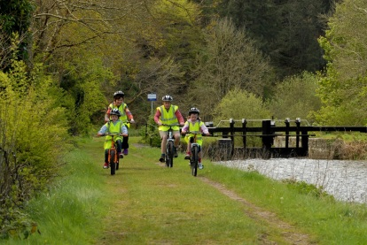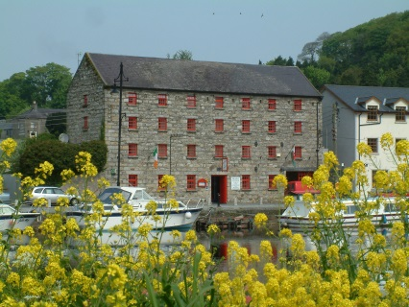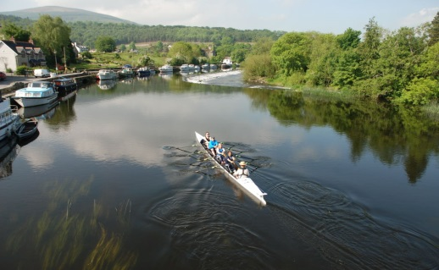
Cycling the Barrow towpath Waterside Guesthouse Heading down the Barrow

Proposed Rowing Tour details

2027 ROWING TOUR BASED IN GRAIGUENAMANAGH, CO. KILKENNY
Rowing on the River Barrow, river Suir and river Nore

Day 1 – Sunday
Afternoon -Arrive Graiguenamanagh
Check in at Waterside Guesthouse
Short walk on river bank to Silaire Wood and Graiguenamanagh Boathouse
Dinner at Waterside
Accommodation at Waterside

Day 2 – Monday
Breakfast at Waterside
Transport to Goresbridge County Kilkenny
Row from Goresbridge to Graiguenamanagh along the Barrow navigation. This includes the unique experience of passing through 6 lock gates on the Barrow navigation. We take a short break for a light lunch on the banks of the river. Finish at Graiguenamanagh.
Dinner at Waterside
Accommodation at Waterside

Day 3 – Tuesday
Breakfast at Waterside
Bus transport to Inistioge, Co. Kilkenny
Row on the river Nore from Inistioge downriver to meet the river Barrow and carry on to New Ross, County Wexford.
Transport back to Graiguenamanagh. When we arrive in Graiguenamanagh it may be a good time to do a walking tour of the village including the fabulous Cushendale woollen mills
Dinner at Waterside, accommodation at Waterside

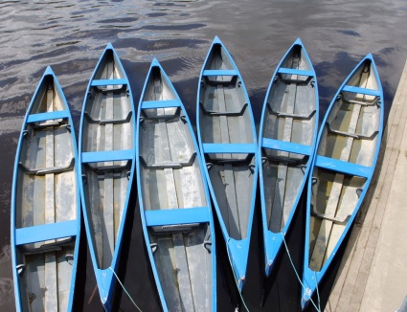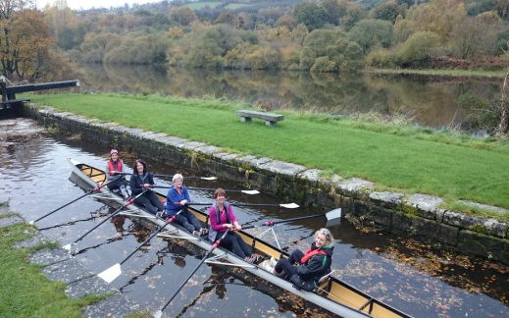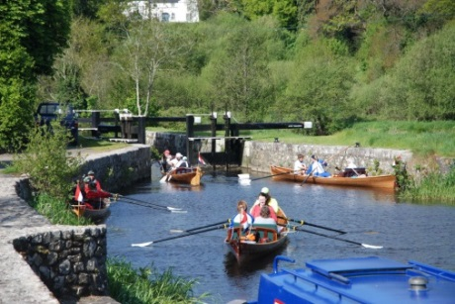
Traditional Barrow Cots Lock gates on the river Barrow Rowing in Graiguenamanagh

Day 4 – Wednesday
Breakfast at Waterside
Transport to Kilkenny City
Walking tour of Kilkenny City
Lunch in Kilkenny City followed by free time for shopping/sightseeing in this small medieval city.
Visit to Kilkenny Castle or one of Kilkenny’s numerous other heritage attractions.
Transport to Graiguenamanagh by minibus
Dinner at Waterside, Accommodation at Waterside
Day 5 –Thursday
Breakfast at Waterside
Transport to Carrick on Suir County Waterford
Row down river on the river Suir from Carrick-on-Suir to Pollrone, close to Waterford City
Transport back to Graiguenamanagh
Dinner at Waterside
Traditional music in the famous Graiguenamanagh pub Mick Doyles.
Accommodation at Waterside

Day 6 – Friday
Breakfast at Waterside
Row from Graiguenamanagh to St. Mullins along the river Barrow. The morning section sees us negotiating 4 more locks. We take a short break for lunch next to the river in St. Mullins.
After lunch we get back in the boats and row on from St. Mullins down river(now we are in tidal water) to arrive at New Ross Boat Club. Transport back to Graiguenamanagh by minibus.
Dinner at Waterside
Accommodation at Waterside

Day 7- Saturday
Breakfast at Waterside
Check out of Waterside and depart(end of tour)

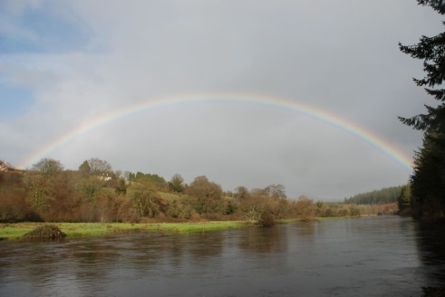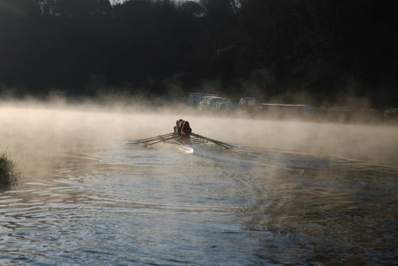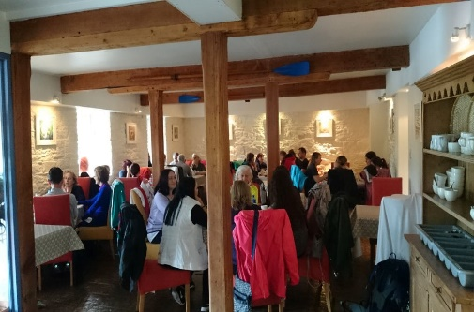
Rainbow on the river Barrow Early morning on the Barrow Restaurant at Waterside

The cost of the above during 2027 is a total of €1,575.00 per person.(July/August supplement of €100.00 per person).
Payment of €1,575.00 per person to Waterside for 6 nights bed and breakfast and evening meals. Lunch day 2,3, 5 and 6. Transport by bus to and from all rowing locations. Traditional music night . Guide for all elements of the tour and safety boat for all days rowing in tidal waters. Lock keepers for Goresbridge to Graiguenamanagh and Graiguenamanagh to St. Mullins. Includes use of all equipment required including good quality touring quads, sculling blades and life jackets if required. Transport of boats and equipment by trailer each day.

Graiguenamanagh is a fantastic outdoor activity destination and alternative activities and heritage attractions are available in the area if weather conditions lead to any cancellation of rowing days. The distance travelled on the water each day can vary and can be affected by weather, tide times etc. We usually aim for about 25km a day, nothing too extreme, but in reality we custom build each tour to accommodate as much as possible the requirements of the visiting club. So let us know what suits you and we will do our best to provide.

If you would like to extend the holiday there are extra days of rowing and other activities available. Just pop us an email and we can give you a price for extra days of rowing or discuss other activities that might interest your group.

Further information available from Brian Roberts at
Irish Rowing Adventures, Waterside , Graiguenamanagh, Co. Kilkenny
Tel 00353-86-8234813 brian@watersideguesthouse.com www.watersideguesthouse.com

Check out Irish Rowing Adventures on Facebook and Instagram

